Create a Resource:

ResourceDemo

Create a Virtual Network

VMNet1

Create Virtual Machine:

VM1

Create 2nd Virtual Machine using VMNet1 network

VM2

Network diagram:

Load Balancer Checking:

New Resource Group

Creating a VM with a Load balancer

Creating new load balancer

Create 2nd VM

For webserver1

For VM2

Global Load Balancer:

Create a new VM

Create new Load Balancer

Make it public, Global

Add front end IP

Create Ip address

**Come to backend pool**

**Create backend pool**

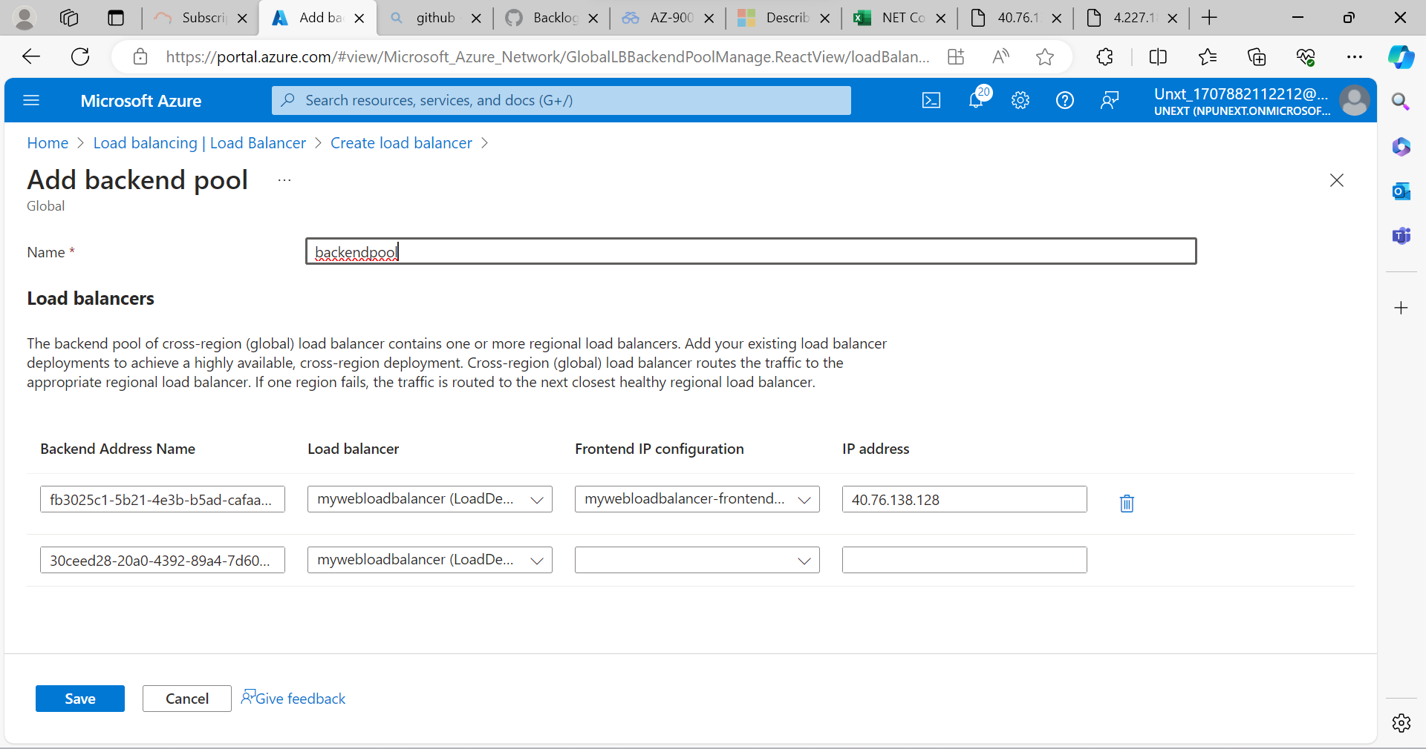

**Inbound rules**

